**CCT College Dublin**

**Assessment Cover Page**

|  |  |
| --- | --- |
| **Module Title:** | Data Preparation |
| **Assessment Title:** | CA1_DataPrep_HDip |
| **Lecturer Name:** | David McQuaid |
| **Student Full Name:** | Bárbara Abreu Costa |
| **Student Number:** | 2023099 |
| **Assessment Due Date:** | Thursday, 20 April 2023 |
| **Date of Submission:** | Saturday, 15 April 2023 |

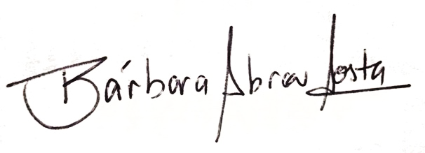

**Declaration**

|  |
| --- |
| By submitting this assessment, I confirm that I have read the CCT policy on Academic Misconduct and understand the implications of submitting work that is not my own or does not appropriately reference material taken from a third party or other source. I declare it to be my own work and that all material from third parties has been appropriately referenced. I further confirm that this work has not previously been submitted for assessment by myself or someone else in CCT College Dublin or any other higher education institution. |